**Inventory Management System**

**A COURSE PROJECT REPORT**

**By**

**Akilash Boopathy.P (RA2111030010138)**

**Under the guidance of Dr.A.Arun**

**In partial fulfilment for the Course**

**18CSC303J-Database Management Systems**

**In**

**School of Computing**



**FACULTY OF ENGINEERING AND TECHNOLOGY SRM**

**INSTITUTE OF**

**SCIENCE AND TECHNOLOGY**

**Kattankulathur, Chengalpattu District MAY 2024.**

1

COLLEGE OF ENGINEERING & TECHNOLOGY

SRM INSTITUTE OF SCIENCE & TECHNOLOGY

S.R.M. NAGAR, KATTANKULATHUR – 603203

# BONAFIDE CERTIFICATE

RegisterNo. RA2111030010153, Certified to be the bonafide work done by MATSA BHARGAV of III Year/VI Sem B. Tech Degree Course in the **Database Management Systems** in **SRM INSTITUTE OF SCIENCE AND TECHNOLOGY,** Kattankulathur during the academic year 2023 – 2024.

SIGNATURE SIGNATURE

Dr. A. Arun Dr. Annapurani Panaiyappan K

Assistant Professor Professor and Head Department of Networking Department of Networking and Communications and Communications SRMIST – KTR. SRMIST – KTR.

**Date:**

# Acknowledgement

We would like to express our gratitude to our Professor, Dr.A.Arunwho gave us the golden opportunity to do this wonderful project on the topic

**"INVENTORY MANAGEMENT SYSTEM"** which also helped us in doing

a lot of research and we came to know about so many new things we are really

thankful to him.

We are also thankful to all the other faculty, teaching and non-teaching staff members of our department for their kind co-operation and help.

Lastly, we would also like to thank our friends who helped us a lot in finishing this project within the limited time. We are making this project not only for marks but to also increase our knowledge.

# Abstract

* In today's dynamic business landscape, effective inventory management stands as a cornerstone for operational efficiency and customer satisfaction. This abstract introduces a comprehensive Inventory Management System (IMS) designed to streamline inventory processes, optimize resource allocation, and enhance decisionmaking capabilities for businesses across diverse sectors.

* The Inventory Management System (IMS) employs advanced technology to automate inventory tracking, replenishment, and forecasting processes. Leveraging state-of-the-art algorithms and machine learning techniques, it accurately predicts demand patterns, minimizes stockouts, and reduces excess inventory, thus mitigating risks associated with overstocking and understocking.

* Key features of the IMS include real-time inventory monitoring, enabling businesses to track stock levels, sales trends, and supplier performance seamlessly. Additionally, it facilitates efficient order management through automated purchase orders, supplier communication, and delivery tracking, thereby fostering smoother procurement cycles and reducing lead times.

* Furthermore, the IMS incorporates robust analytics tools to generate actionable insights from vast inventory datasets. Through customizable dashboards and reports, stakeholders gain valuable visibility into key performance indicators (KPIs), allowing for informed decision-making and strategic planning. Moreover, integration with existing enterprise systems ensures seamless data flow and interoperability across departments, optimizing operational workflows and enhancing organizational agility.

In summary, the Inventory Management System (IMS) presented herein offers a scalable, userfriendly solution tailored to the evolving needs of modern businesses. By enhancing inventory visibility, streamlining processes, and empowering stakeholders with actionable insights, it serves as a catalyst for driving operational excellence, reducing costs, and maximizing profitability in today's competitive marketplace, businesses of all sizes, with customizable features to adapt to evolving market trends.

**Table of Contents**

**1. INTRODUCTION**

* 1. Overview
  2. Scope
  3. Working
  4. Purpose
  5. Goals of proposed actions
  6. User characteristics
  7. Technical Feasibility
  8. Advantages

**2. ER Diagram**

* 1. **Relationship Assumptions for ER Diagram**
  2. **Relationships according to the requirements**
     1. One-to-One Binary Relationships
     2. One-to-Many Binary Relationships
     3. Many-to-Many Binary Relationships
        1. **Relational Schema**
        2. **Normalisation of Schema**
        3. **Queries**
  3. Create Table & Insert Queries
  4. SQL Queries

**6. CONCLUSION**

**List of Figures**

|  |  |
| --- | --- |
| **Figure** | **Description** |
| 1 | Architecture diagram |
| 2 | Use Case Diagram |
| 3 | ER Diagram |
| 4 | Sample Web Application – Online Shopping Management System |
| 5 | Sample Web Application Landing Page |

## Introduction

An inventory management system is the combination of technology (hardware and software) and processes and procedures that oversee the monitoring and maintenance of stocked products, whether those products are company assets, raw materials and supplies, or finished products ready to be sent to vendors or end consumers.

This system can widely be used by normal shops, departmental stores or MNCs for keeping a proper track of the stock. It also consists of information like manager details, customer details etc.

With the help of this system, we can fix a minimum quantity of any inventory below which we need to place an order for that inventory. This will help us in good sales results and never the out-of-stock stage for any inventory.

**SCOPE:**

This will help us in maintain the exact count of any product. Can help us to set minimum quantity of any product below which we can order the product from manufacturer. Can reduce duplicate entries.

**WORKING:**

This application will have different front ends for different kinds of users. The person who is sitting on the billing counter will have access to only modify the quantity of any product i.e., he/she can either generate an invoice for any sold product or can generate a return note for any returns from any customer. The manager will have the access to modify the rates if there exist any dynamic price inventory. The owner of the firm will have the access to generate the final report which will be consisting of sales done on any particular day, the total sales on any particular counter or by any salesperson.

**1.4 Purpose:**

INVENTORY MANAGEMENT must tie together the following objectives , to ensure that there is continuity between functions: • Company’s Strategic Goals

* Sales Forecasting
* Sales & Operations Planning
* Production & Materials Requirement Planning.

*Inventory Management* must be designed to meet the dictates of market place and support the company’s Strategic Plan. The many changes in the market demand, new opportunities due to worldwide marketing, global sourcing of materials and new manufacturing technology means many companies need to change their Inventory Management approach and change the process for Inventory Control.

*Inventory Management* system provides information to efficiently manage the flow of materials, effectively utilize people and equipment, coordinate internal activities and communicate with customers. Inventory Management does not make decisions or manage operations, they provide the information to managers who make more accurate and timely decisions to manage their operations.

INVENTORY is defined as the blocked Working Capital of an organization in the form of materials. As this is the blocked Working Capital of organization, ideally it should be zero. But we are maintaining Inventory. This Inventory is maintained to take care of fluctuations in demand and lead time. In some cases, it is maintained to take care of increasing price tendency of commodities or rebate in bulk buying.

**1.6 Goals of proposed system**

1.**Planned approach towards working: -** The working in the organization will be well planned and organized. The data will be stored properly in data stores, which will help in retrieval of information as well as its storage. 2.**Accuracy: -** The level of accuracy in the proposed system will be higher. All operation would be done correctly and it ensures that whatever information is coming from the center is accurate.

3.**Reliability:** - The reliability of the proposed system will be high due to the above stated reasons. The reason for the increased reliability of the system is that now there would be proper storage of information.

4.**No Redundancy: -** In the proposed system utmost care would be that no information is repeated anywhere, in storage or otherwise. This would assure economic use of storage space and consistency in the data stored.

5.**Immediate retrieval of information: -** The main objective of proposed system is to provide for a quick and efficient retrieval of information. 6. **Immediate storage of information: -** In manual system there are many problems to store the largest amount of information.

7. **Easy to Operate: -** The system should be easy to operate and should be such that it can be developed within a short period of time and fit in the limited budget of the user.

**1.7 Background:**

This application is nowadays a basic use of any company, firm, shop or departmental store because stock maintenance, stock forecasting are some things which are very essential these days for earning great profits.

In ancient times we need to maintain the complete inventory in paper pen method. The ancient method is quite un-easy, uncomfortable, and sometimes inaccurate. For overcoming this problem, we came with a solution of inventory management system. From this system we can generate invoice for each purchase. In addition to this we can have the employee details, customer details in this system.

In short, we can call this as all-in-one system...!!

**User Characteristics:**

Every user should be:

1.Comfortable with computer.

2.Should have knowledge of internet explorer.

3.He must also have basic knowledge of English too.

### 1.9 Technical Feasibility: Back End

In this project we have only implemented the back end of the system which is designed on “SQL Plus”

On this sequence query language, we created 10 tables named:

1. Brands
2. invoice user
3. Categories
4. Products
5. Stores
6. Providers
7. Customer cart
8. Select product
9. Transaction
10. Invoice

### ADVANTAGES

1. **Inventory Balance.** Good inventory management helps you figure out exactly how much inventory you need. This makes it easier to prevent product shortages and keep just enough inventory on hand without having too much.
2. **Inventory Turnover.** Need to keep a high [inventory turnover ratio to](https://www.fishbowlinventory.com/blog/2010/08/05/inventory-turnover-ratio/) ensure your products aren’t spoiling, becoming obsolete or sucking up your working capital. Calculate how many times your inventory sells in a year and see where you can make better use of your resources.
3. **Repeat Customers.** Good inventory management leads to what every business owner wants – repeat customers. You want your hard-earned customers to keep coming back to your business to meet their needs. One way to do this is to make sure you have what they’re looking for every time they come.
4. **Accurate Planning.** Using smart inventory management, you can stay ahead of the demand curve, keep the right number of products on hand and plan ahead for seasonal changes. This goes back to keeping your customers happy all year long.
5. **Warehouse organization.** If we know which products are your top sellers and what combinations of products your customers often order together, you can optimize your warehouse setup by putting those products close together and in easily accessible places. These speeds up the picking, packing and shipping processes.
6. **Employee Efficiency.** We can empower your employees to help you manage inventory. Training employees to use barcode scanners, [inventory management software and](https://www.fishbowlinventory.com/learn-more/?utm_source=blog&utm_medium=inventory-system-software&utm_campaign=inv-blog-top-10-benefits-inventory-management) other tools helps them make better use of their time, and it helps your business make better use of its resources, both human and technological.
7. **Inventory Orders.** If you’ve done a good job keeping track of how much inventory you have on hand, you can make smarter decisions about when and what to order. Inventory management software lets you speed up the ordering process. You can simply scan a product barcode and type in some information to place an order and generate an invoice.
8. **Inventory Tracking.** If you have multiple locations, then inventory management becomes even more important because you need to coordinate your supplies at each location depending on differences in demand and other factors.
9. **Time Saving.** Inventory management is a great timesaving tool. By keeping track of all the products, you have on hand and on order, you can save yourself the hassle of doing inventory recounts to make sure your records are accurate. This once again requires inventory management software.

**10.Cost Cutting.** When your inventory is humming along efficiently through your facilities, you can bet you’ll save a lot of money. Inventory management helps you avoid wasting money on slow-moving products so you can put it to better use in other areas of your business.

## ER DIAGRAM

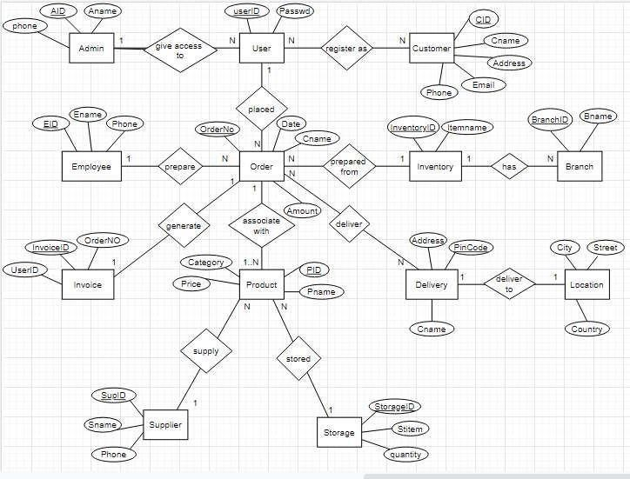

**2.2** **Relationships according to the requirements**

2.2.1 One-to-One Binary Relationships

(a)Single user can ride in one product at a time (1:1)

(b) One customer service representative can take one feedback at a time

(1:1)

2.2.2 One to Many Binary Relationships

1. Single user can have multiple inventory details (1:N)

1. Single user can have multiple bills details (1:N)

1. Single user can give many feedback (1:N)

2.2.3 Many to Many Binary Relationships

(a) Many products can have many stocks (M:N) (b) Many inventories can have many items (M:N)

**RELATIONAL SCHEMA**

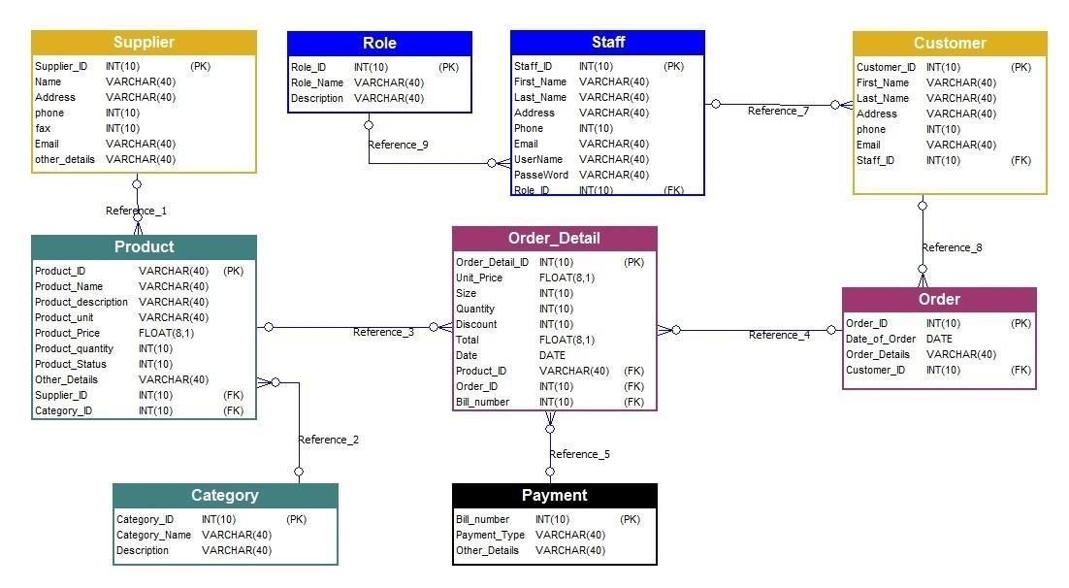

**Normalization of schema**

**#1NF**

*After performing First-Normal Form, a single table was generated:*

***OrderHistory****.*

***Inventory*** *(* ***ItemNumber*** *, ItemDescription, CurrentSalePrice, InStockCount, ReorderValue)*

***OrderHistory*** *(* ***ItemNumber, PONumber*** *, SupplierNumber, Date, Quantity,*

*Cost)*

**#2NF**

*After performing First-Normal Form, a single table was generated:*

***PurchaseOrder****.*

***OrderHistory*** *(* ***ItemNumber, PONumber*** *, Quantity, Cost)*

***PurchaseOrder*** *(* ***PONumber*** *, SupplierNumber, Date)*

**#3NF**

*When performing Third-Normal Form, no transitive dependencies were identified, and the tables have not changed.*

*The final set of entities after completing Third-Normal-Form are as follows:*

***Inventory*** *(* ***ItemNumber*** *, ItemDescription, CurrentSalePrice, InStockCount, ReorderValue)*

***OrderHistory*** *(* ***ItemNumber, PONumber*** *, Quantity, Cost)*

***PurchaseOrder*** *(* ***PONumber*** *, SupplierNumber, Date)*.

OUTPUT:

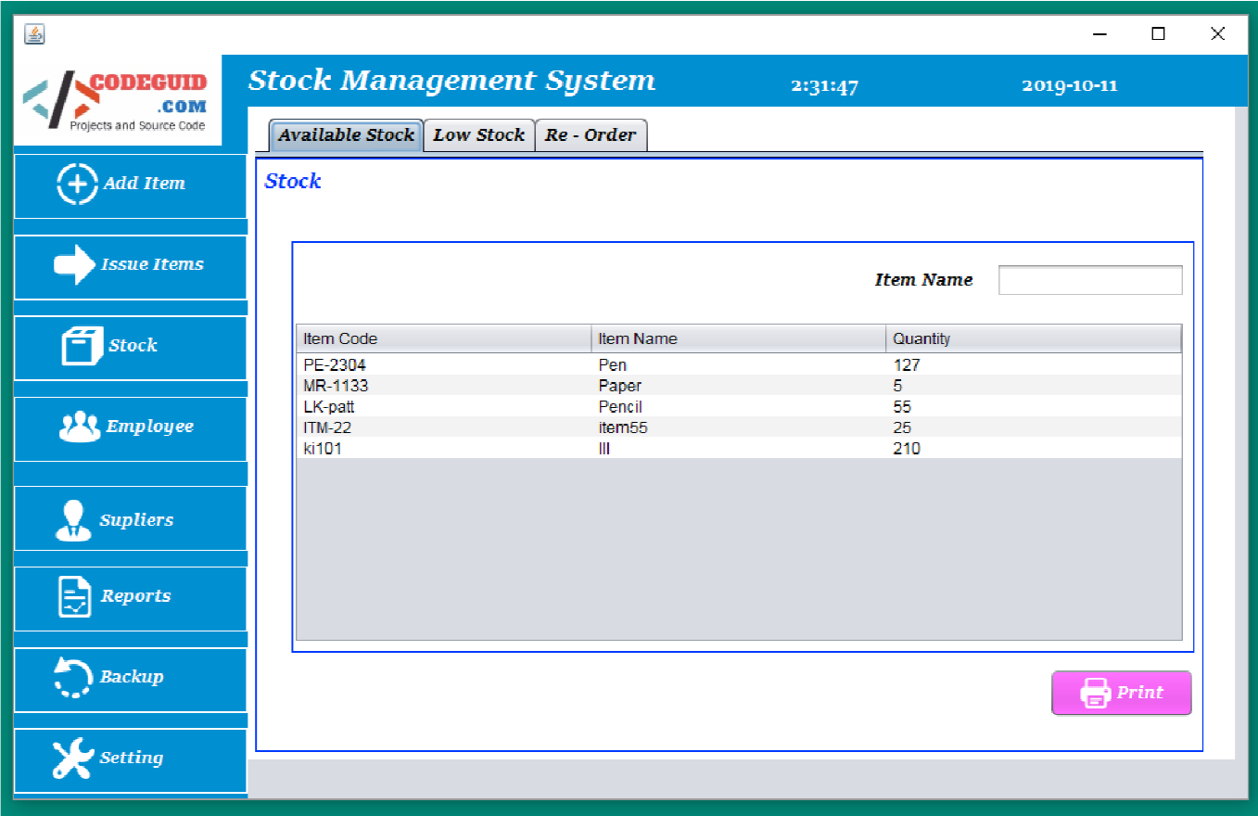

### CONCLUSION

In conclusion, our comprehensive back-end software solution represents a significant leap forward in empowering businesses to thrive in today's competitive environment. By seamlessly integrating advanced features such as stock management, warehouse optimization, CRM functionalities, and transaction tracking, our software equips businesses with the tools they need to enhance efficiency, improve customer relationships, and drive sustainable growth.

With intuitive interfaces and powerful analytics capabilities, our software streamlines complex processes, enabling businesses to make data-driven decisions and adapt quickly to changing market conditions. By leveraging technology to automate routine tasks and provide actionable insights, businesses can focus their efforts on innovation, expansion, and delivering exceptional value to their customers.

As businesses navigate the challenges and opportunities of the digital age, our back-end software solution serves as a strategic asset, empowering them to stay ahead of the curve and achieve their goals. Whether it's maintaining optimal inventory levels, personalizing customer interactions, or optimizing financial performance, our software is designed to support businesses every step of the way.

In a rapidly evolving business landscape, investing in the right technology can make all the difference. With our back-end software solution, businesses can unlock new possibilities, drive operational excellence, and chart a course toward long-term success.

**REFERNCES:**

**Books:**

**"Inventory Management: Principles, Concepts and**

**Techniques" by Tapan K. Panda**

**"The Handbook of Logistics and Distribution**

**Management" by Alan Rushton, Phil Croucher, and**

**Peter Baker**

**"Operations Management: Sustainability and**

**Supply Chain Management" by Jay Heizer and**

**Barry Render**

**Online Courses:**

**Coursera offers courses like "Supply Chain**

**Management" and "Operations Management" which cover inventory management concepts.**

**LinkedIn Learning has courses such as "Inventory Management Foundations" that provide practical insights into managing inventories.**

**Academic Journals and Articles:**

**"Journal of Operations Management" and "International Journal of Production Economics" often publish research articles on inventory management strategies and techniques.**

**Search platforms like Google Scholar or databases like PubMed can help you find specific articles related to inventory management.**

**Industry Reports and Whitepapers:**

**Deloitte, McKinsey, and PwC often publish reports on supply chain and inventory management trends.**

**Industry-specific publications and organizations may offer insights tailored to particular sectors, such as retail, manufacturing, or healthcare.**

**Online Forums and Communities:**

**Websites like Stack Overflow, Reddit's r/inventorymanagement, and LinkedIn groups dedicated to supply chain management are great places to ask questions and learn from others' experiences.**

**Software Documentation and Case Studies:**

**Explore documentation and case studies provided by inventory management software vendors like SAP, Oracle, or Fishbowl. These resources often contain practical insights and implementation guidelines.**

**Consulting Firms and Experts:**

**Engage with supply chain consultants or experts who specialize in inventory management. They can provide tailored advice and guidance based on your specific business needs.**

**Webinars and Conferences:**

**Attend webinars hosted by industry experts or conferences focused on supply chain management and logistics. These events often feature presentations and panel discussions on inventory management best practices.**